1. **Agenda**:
   1. We will create a Fanout exchange and a few queues.
   2. Then bind the queues to the Fanout exchange.
   3. Then publishing msg to this Fanout exchange.
   4. Then consuming msg from the queues.
2. 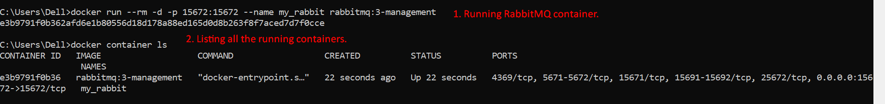
3. 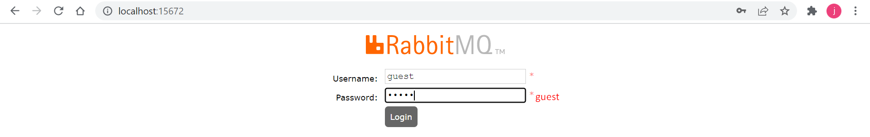
4. Let’s create our first exchange.
5. In the below slide, we’re trying to understand the various settings/arguments for an exchange.  
   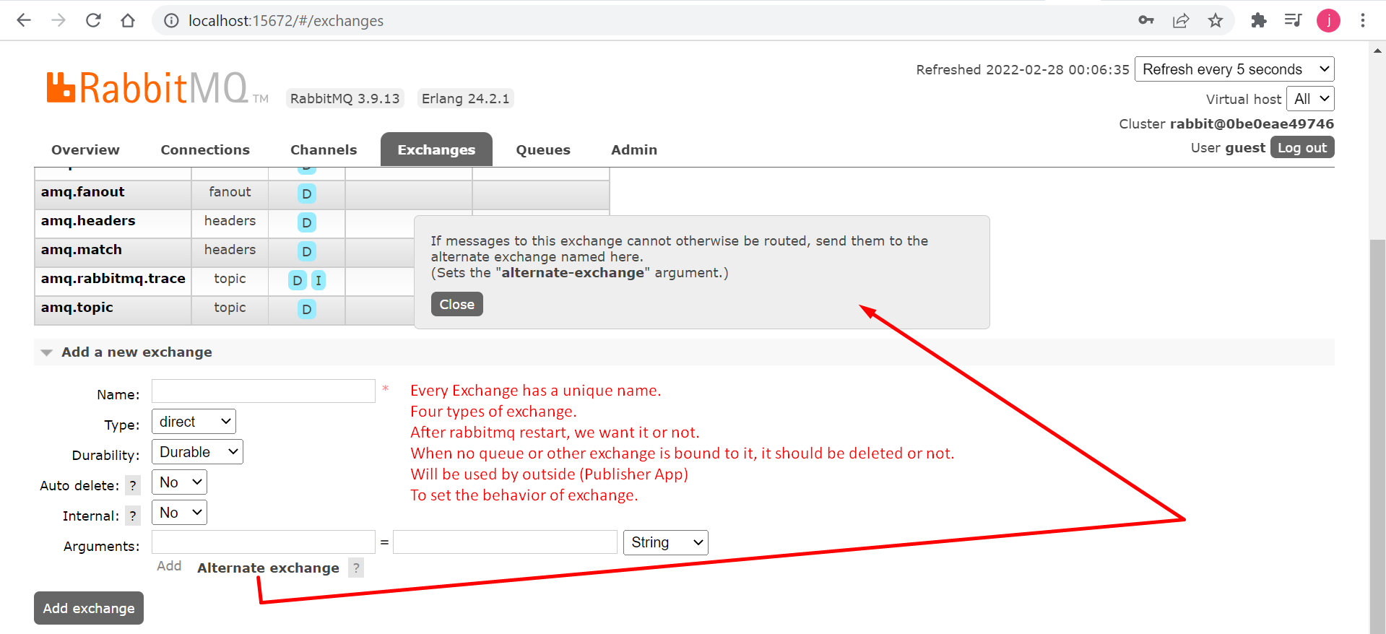
6. 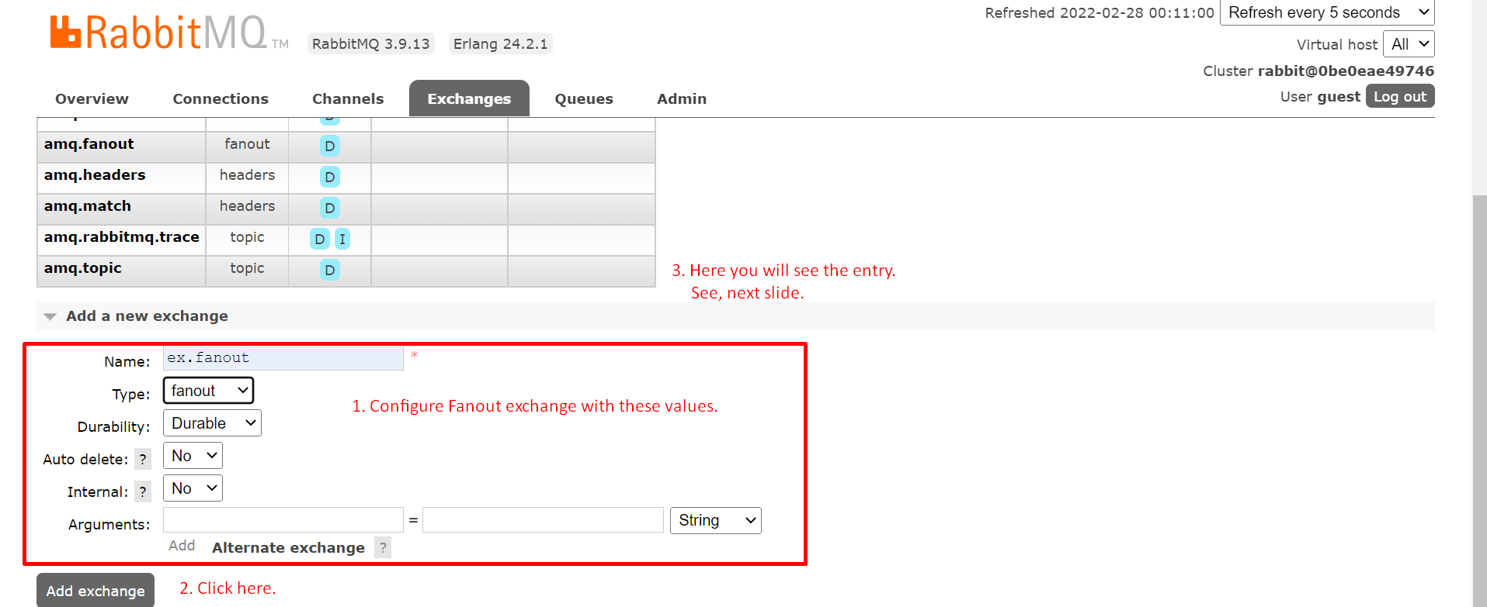
7. 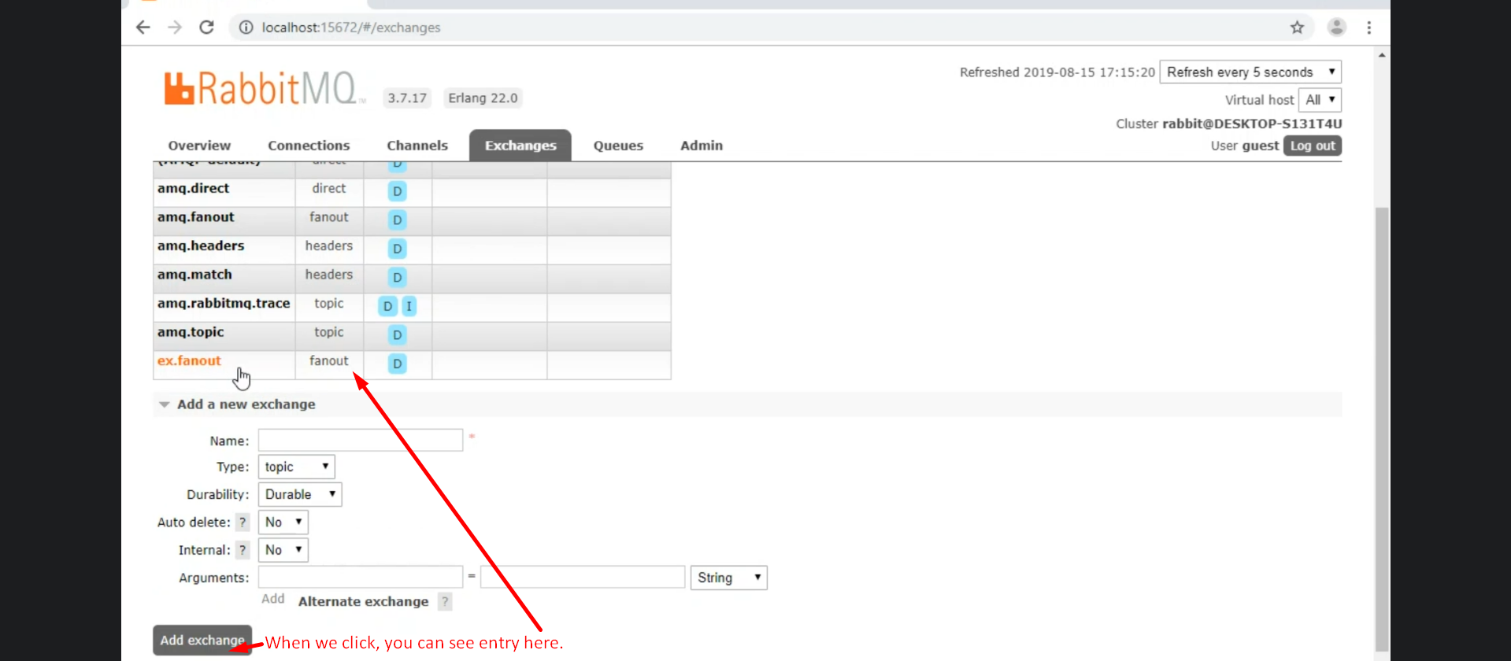
8. Let’s create two queues.   
   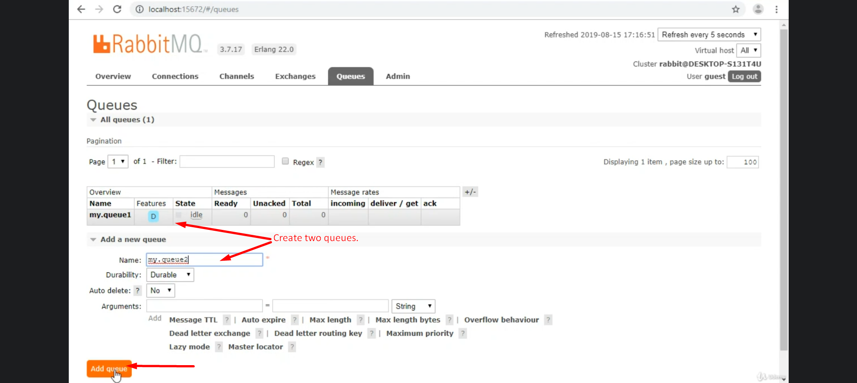 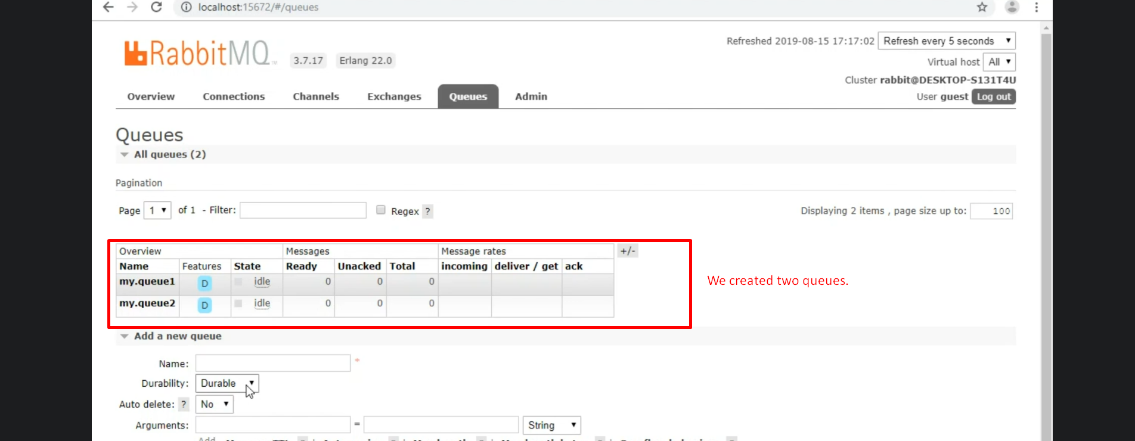
9. Let’s bind these two queues with fanout exchange we created.  
   

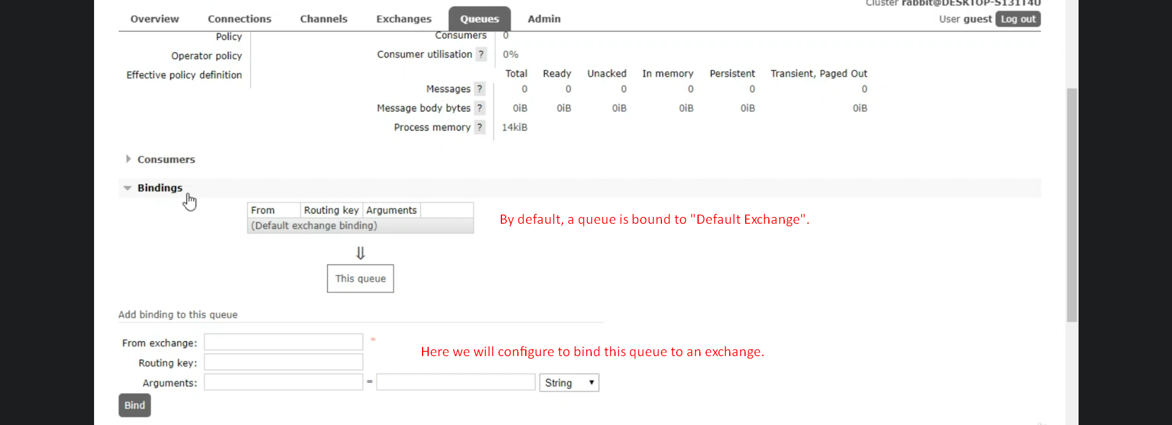

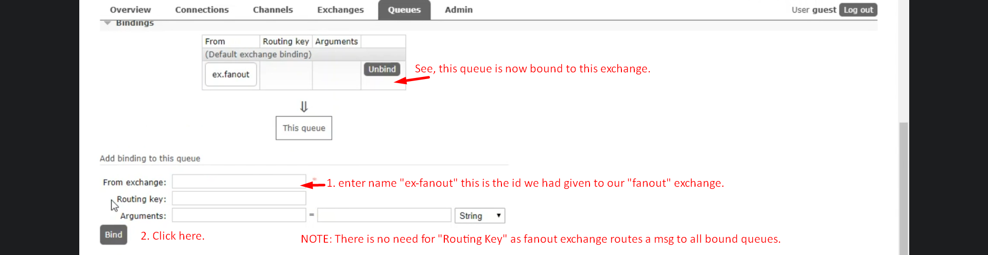 

Now bind the second queue to too the same fanout.

1. Let’s now publish some text messages.  
   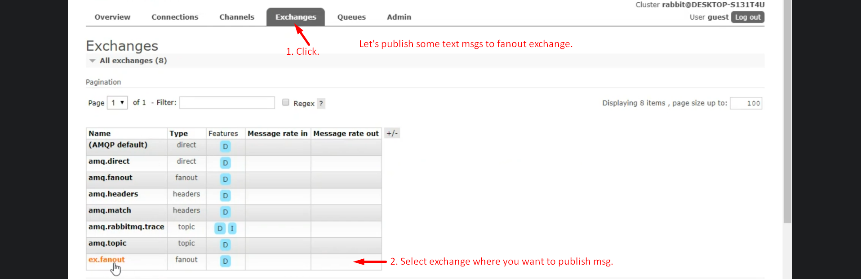  
   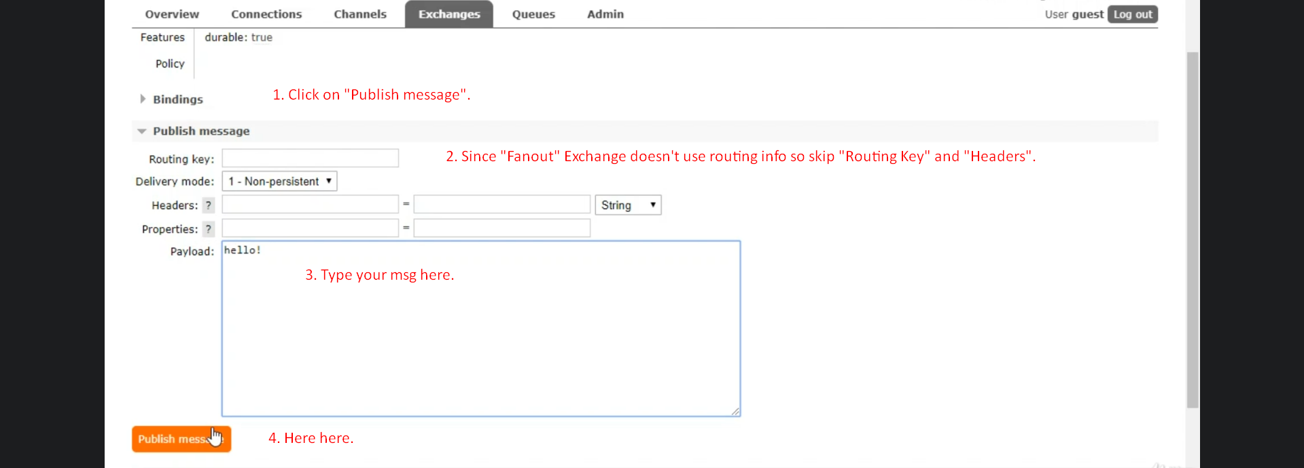 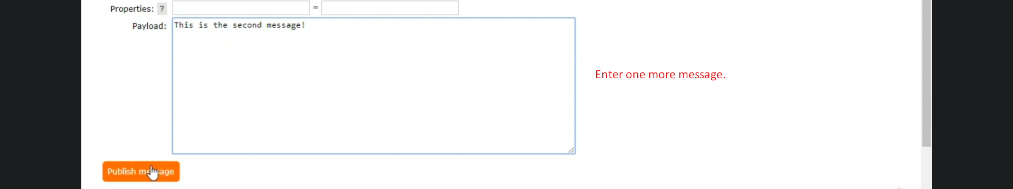
2. Let’s see the two messages in the queue.  
   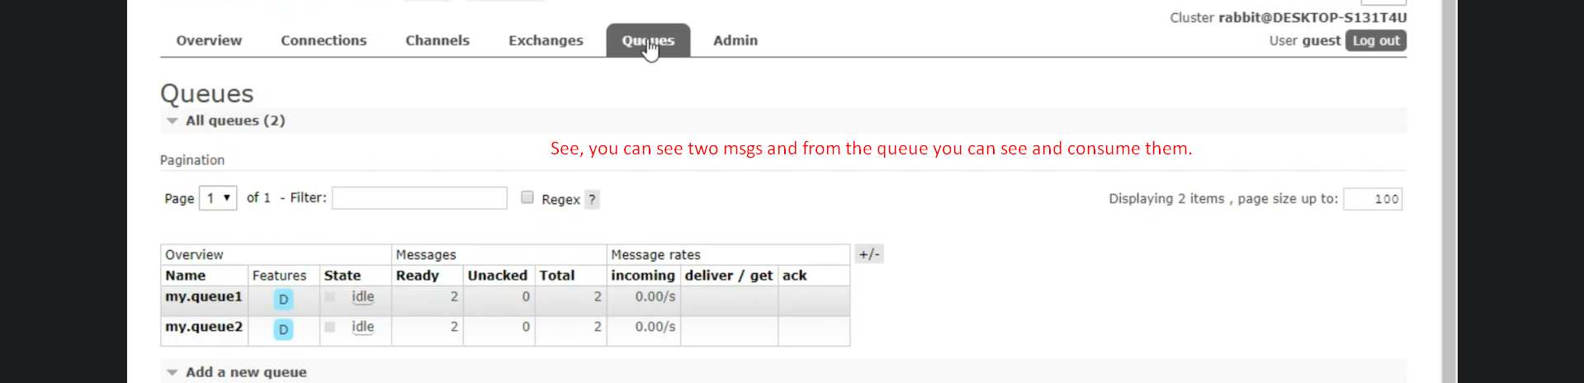
3. Let’s see and consume messages from a queue.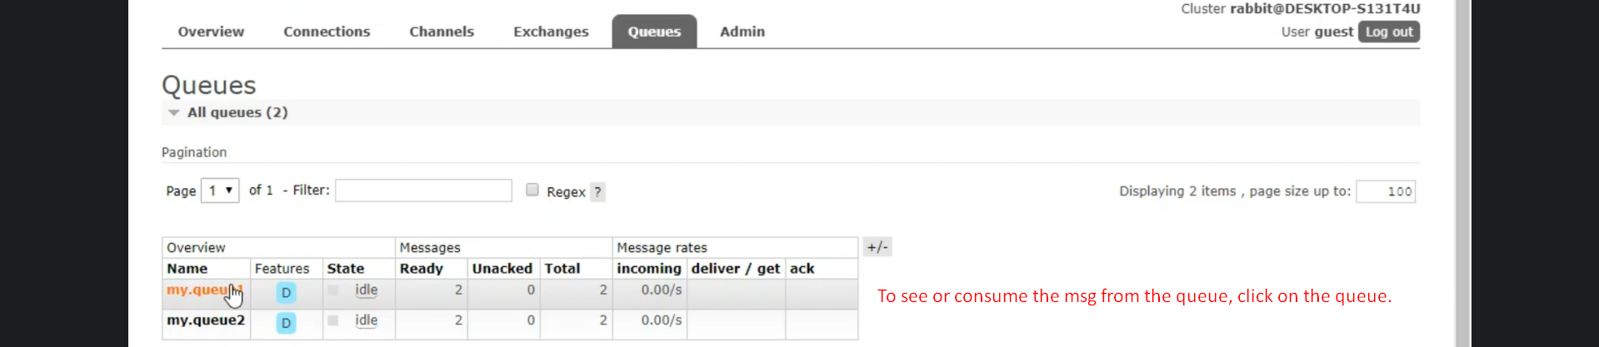  
   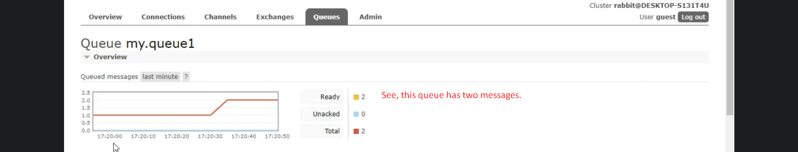  
   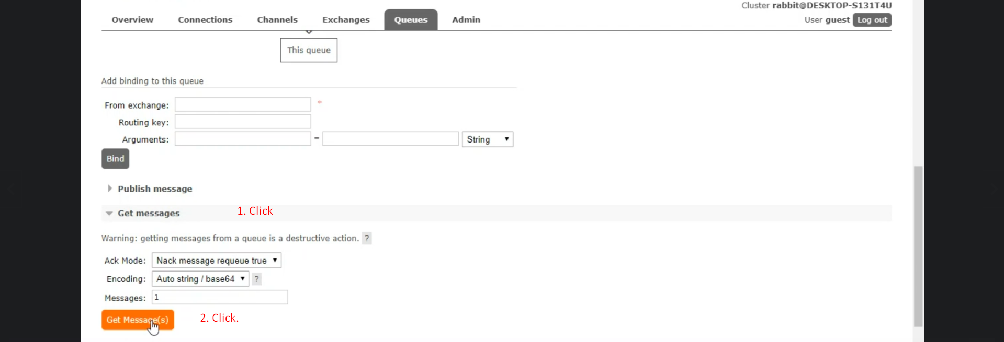  
   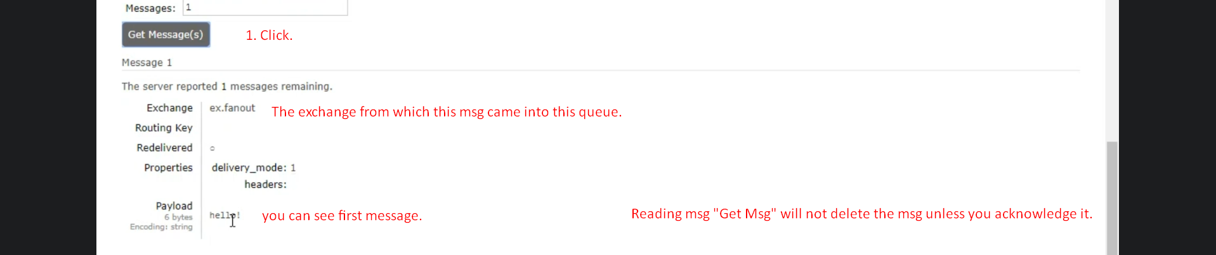 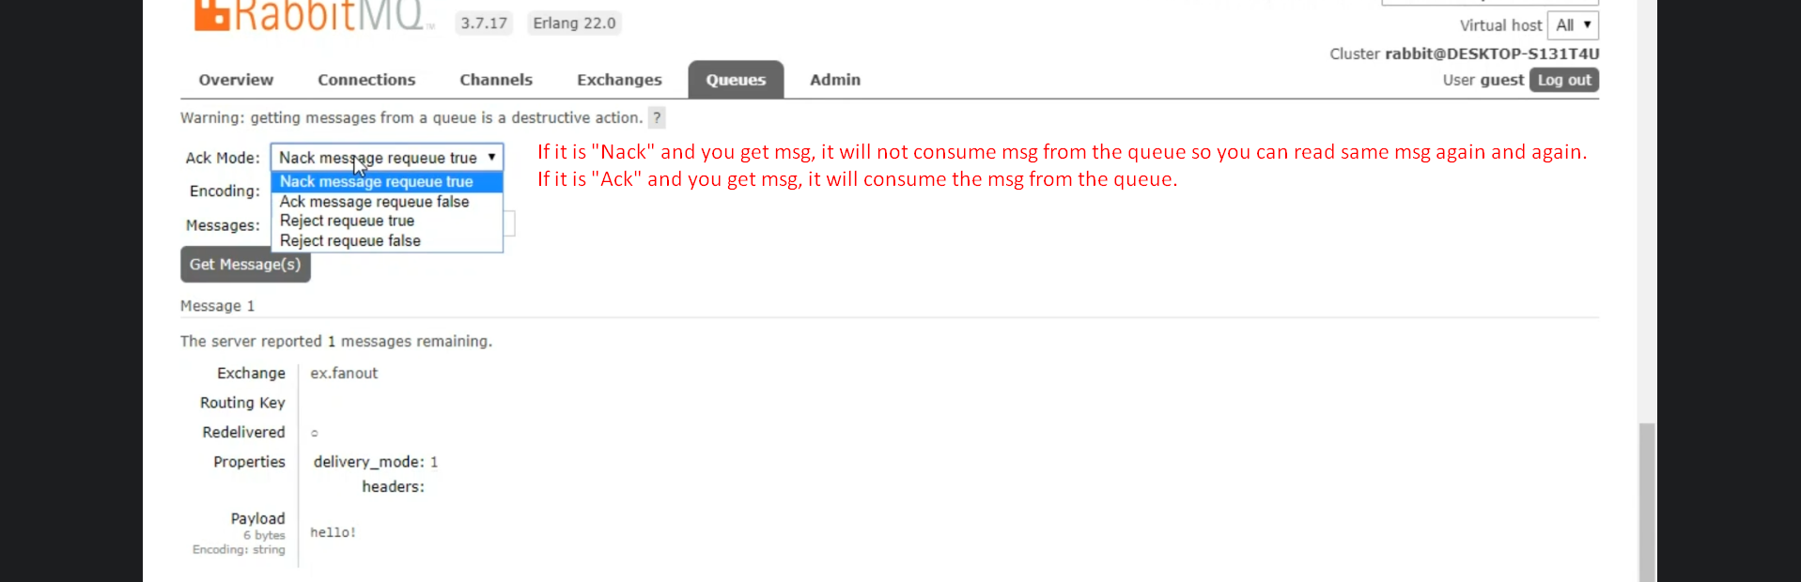 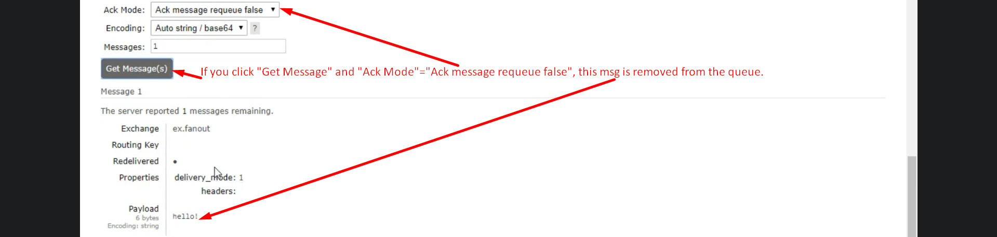
4. Let’s delete queue and exchange.  
   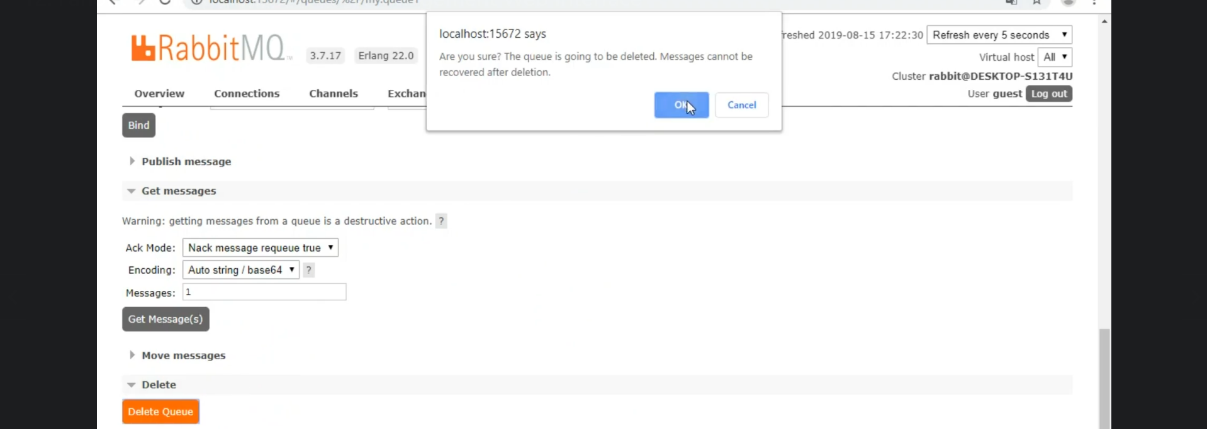 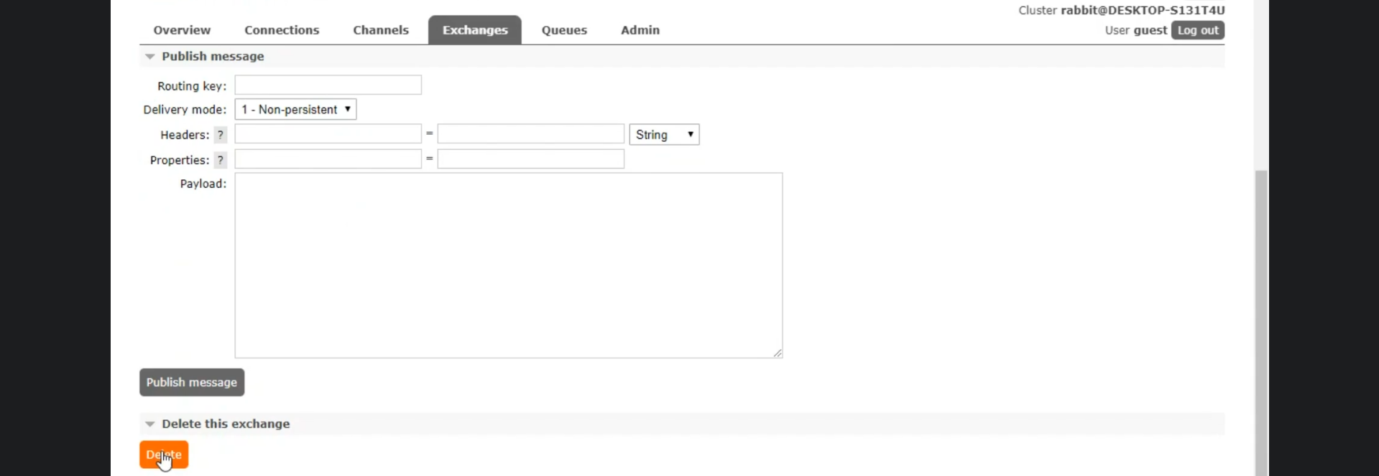
5. 